Consider the pushdown automaton with the following transition rules:
- δ(q, 0, Z₀) = { (q, XZ₀) }
- δ(q, 0, X) = { (q, XX) }
- δ(q, 1, X) = { (q, X) }
- δ(q, ε, X) = { (p, ε) }
- δ(p, ε, X) = { (p, ε) }
- δ(p, 1, X) = { (p, XX) }
- δ(p, 1, Z₀) = { (p, ε) }
From the ID (p, 1101, XXZ₀) which of the ID's can NOT be reached?
PUSHDOWN AUTOMATON: DEFINITION:
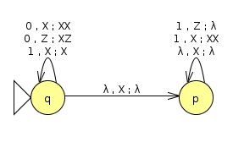Pushdown automaton
DERIVATIONS TREE:
(p, 1101, XXZ₀)
(p, 101, XXXZ₀) | (p, 1101, XZ₀)
(p, 01, XXXXZ₀) | (p, 101, XXZ₀) | (p, 1101, Z₀) | (p, 101, ε)
 | (p, 01, XXXZ₀) | (p, 101, XZ₀) | (p, 101, Z₀)
 |  | (p, 01, XXZ₀) | (p, 01, ε)
 |  | (p, 01, XZ₀)
 |  | (p, 01, Z₀)

